**UC 1: Registration**

|  |  |
| --- | --- |
| **Precondition: System does not have a registered account in Squirrel (UTA mobile vending system) for “Student/ Staff/ Faculty/non-student”.**  **Note: Registration process is the same for all three system users.** | |
| **Actor: System User** | **System: Squirrel** |
|  | 0.System Displays the Application LogIn screen (figure 1)**.** |
| **1. TUCBW** The System User selects the Registration function on Application LogIn screen. | 2.System Displays the registration form in registration screen (figure 2). |
| 3.System user fills the details and selects register. | *4. System displays successful message ‘Registered’ (figure 3) and user is redirected back to Application LogIn screen (figure 3). |
| **5.TUCEW** System user sees the successful message ‘Registered’ and sees the return to the Application LogIn screen. |  |
| **Post condition: The system creates a new account for the system user in the system. (Here is for Student/ Staff/ Faculty/non-student).** | |

Figure 1 Figure 2 Figure 3

**UC 2: Login**

|  |  |
| --- | --- |
| **Precondition: System has account in Squirrel (UTA mobile vending system) for the system user (General Role, applied to all users).** | |
| **Actor: System User** | **System: Squirrel** |
|  | 0.System Displays the Application LogIn screen (figure 4)**.** |
| **1. TUCBW** The System User enters the username, password and selects Login. | *2.System redirects the different system user Home screen based on role selected in registration screen if user credentials are correct.  (i) Student/ Staff/ Faculty/non-student will be shown Home screen (figure 5).  (ii) Vending Operator will be shown Home screen (figure 6).  (iii) Vending Manager will be shown Home screen (figure 7). |
| **3.TUCEW** System user gains access into the system. System user see their functions based on the role. |  |
| **Post condition: The system directs the user to his/her home screen where he/she is eligible to access appropriate user functions based on the role.** | |

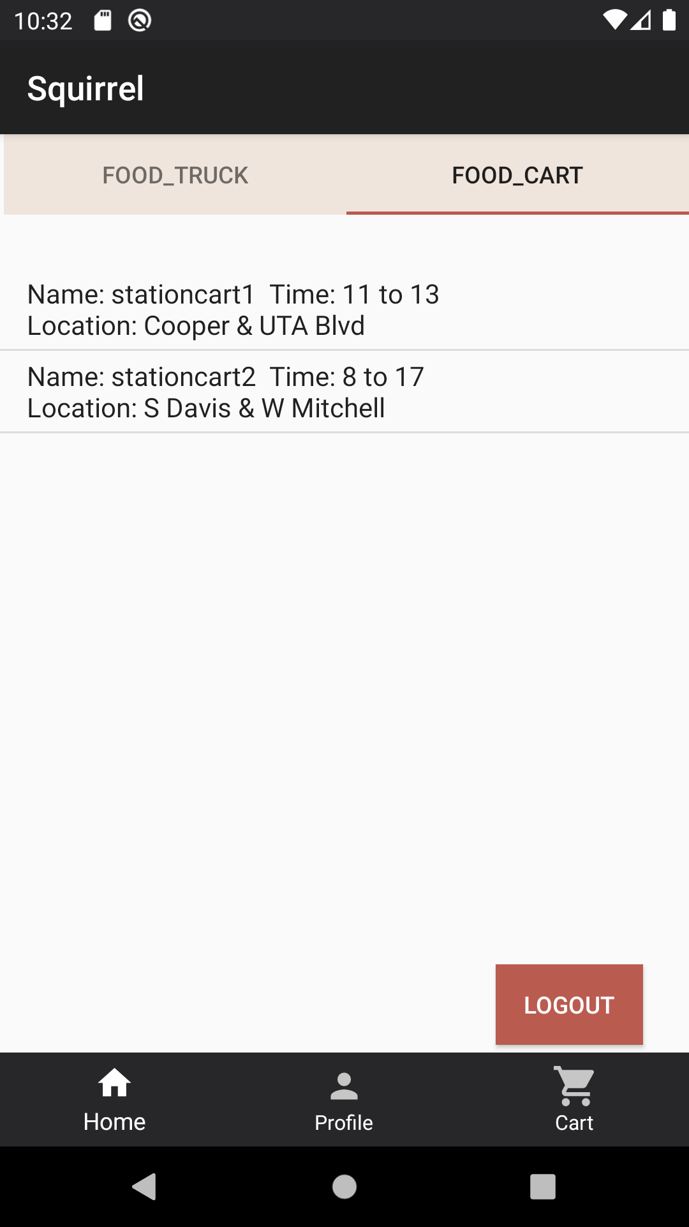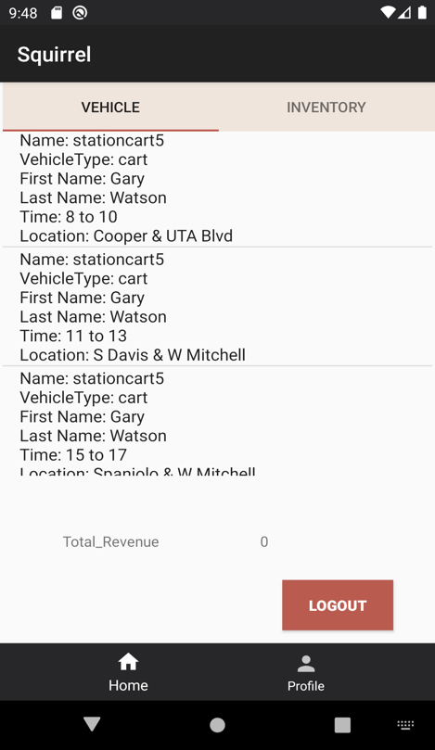

Figure 4 Figure 5(Student/ Staff/ Figure 6(Operator Home Page)

Faculty/non-student)

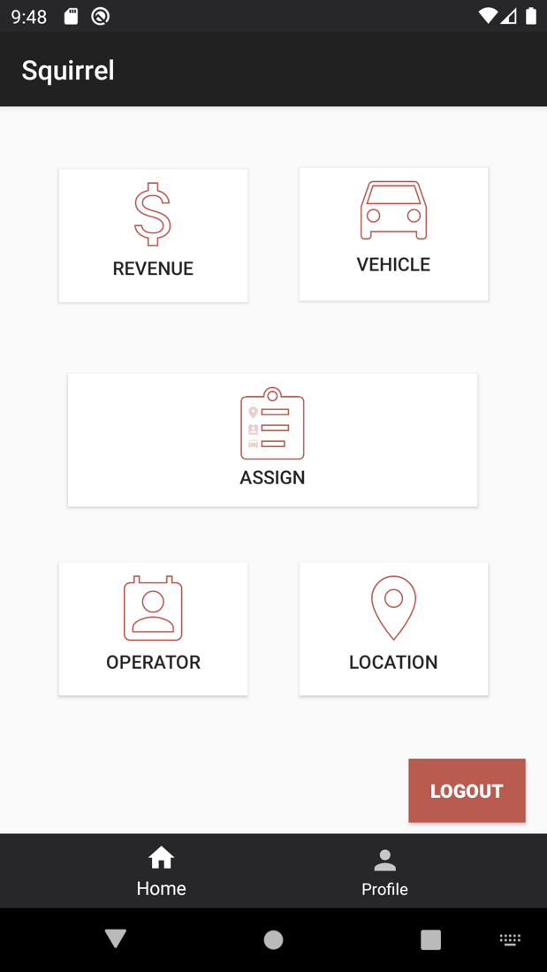

Figure 7(Manager Home Page)

**UC 2.1: Forgot Password? (Reset Password)**

|  |  |
| --- | --- |
| **Precondition: System has the user’s account in the application. (General Role, applied to all users).** | |
| **Actor: System User** | **System: Squirrel** |
|  | 0.System Displays the Application LogIn screen (figure 8)**.** |
| **1. TUCBW** The System User selects forgot password function to reset the password. | 2.System Displays the email address screen. (figure 9) |
| 3. The System user enters his/her email address and selects “CONFIRM EMAIL”. System user can navigate back to the login screen after selecting “BACK”. | *4. System displays enter new password and confirm password screen to the System user after displaying “Valid Email” Toast. (figure 10) |
| 5. System user enters the new password and confirm password and selects “CHANGE PASSWORD”. | **\***6**.** System navigate to the login screen once the system user selects “CHANGE PASSWORD” and displays the toast message “Password changed successfully”. (figure 11) |
| **7. TUCEW** System user sees the application Login screen as well as Toast message.(figure 12) |  |
| **Post condition: The system directs the system user to login screen and updates the password in the system.** | |

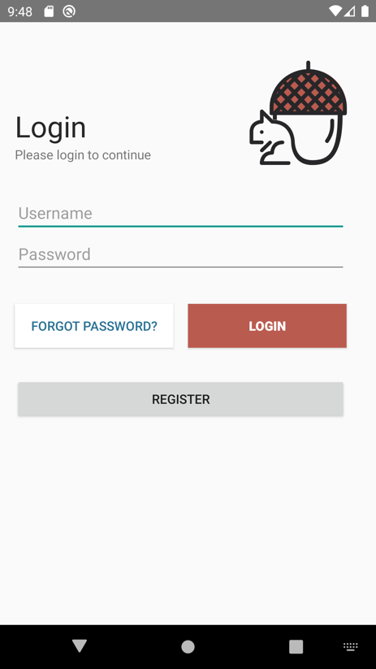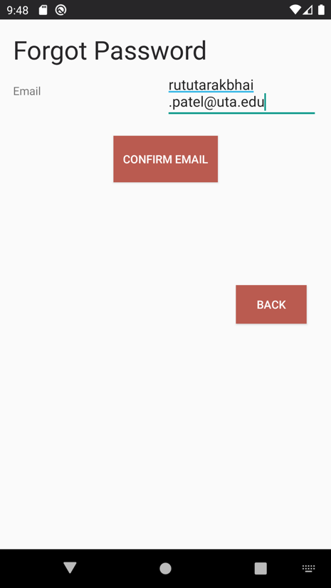

Figure 8 Figure 9 Figure 10

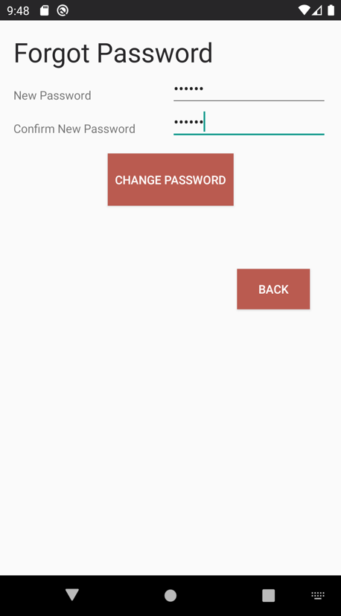

Figure 11 Figure 12

**UC 3: Logout**

|  |  |
| --- | --- |
| **Precondition: The system shows the system user (general for all roles) as already logged in into the application.** | |
| **Actor: System User** | **System: Squirrel** |
|  | 0.System Displays certain page. (figure 13)**.** (Logout is accessible from all screens) |
| **1. TUCBW** The System User selects Logout from his/ her current screen. | 2.System displays successful message ‘Logout Successful’ and System user is redirected back to the application’s LogIn screen (figure 14). |
| **3.TUCEW** System user sees the application Login screen. |  |
| **Post condition: The system logs out the system user from the Squirrel app (UTA mobile vending system). (General for all users)** | |

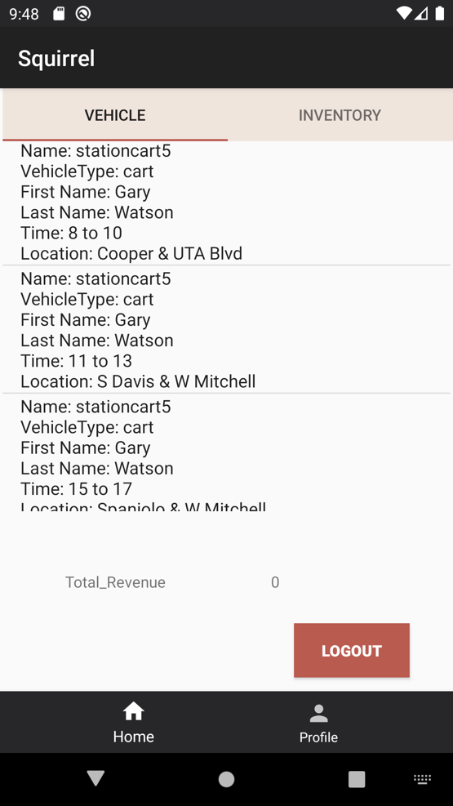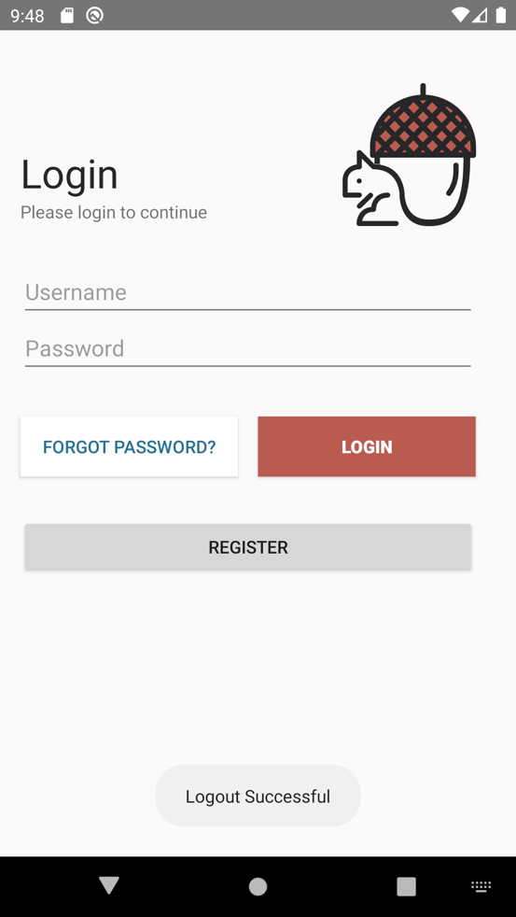

Figure 13 Figure 14

**UC 4: View Profile**

|  |  |
| --- | --- |
| **Precondition: The system shows system user as already logged in. (General for all users)** | |
| **Actor: System User** | **System: Squirrel** |
|  | 0.System Displays the screen with bottom navigation bar which contain profile function. (Bottom navigation is accessible from all screens) |
| **1. TUCBW** The System User selects profile (profile function) from bottom navigation bar. | *2.System displays all the user’s information in view profile screen. (figure 13 for manager and Figure 15 for operator user).   1. Student/ Staff/ Faculty/non-student users have more unique functions presented in their profile screen, such as add card information. (figure 14). |
| **3.TUCEW** System user sees his/ her information. User can return to the application Home screen (unique based on the role) through the bottom navigation. |  |
| **Post condition: The system displays the profile of the logged in user. (General for all users)** | |

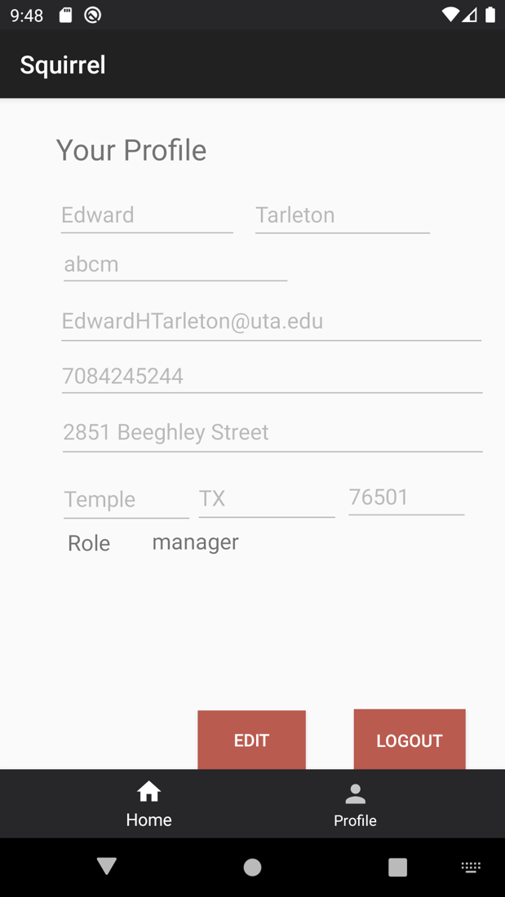 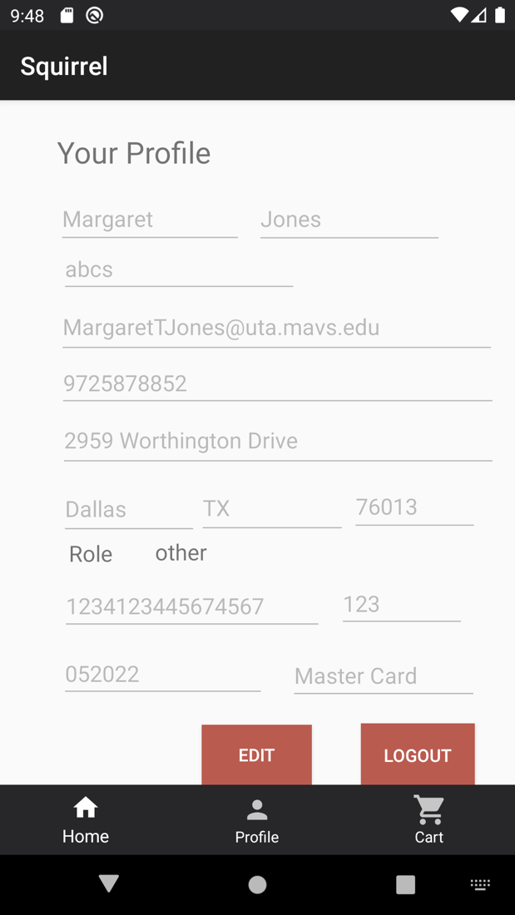

Figure 13(Manager View Profile Screen) Figure 14(For Student/Staff/Non-Student/Faculty View . Profile screen)

Figure 15 (For Operato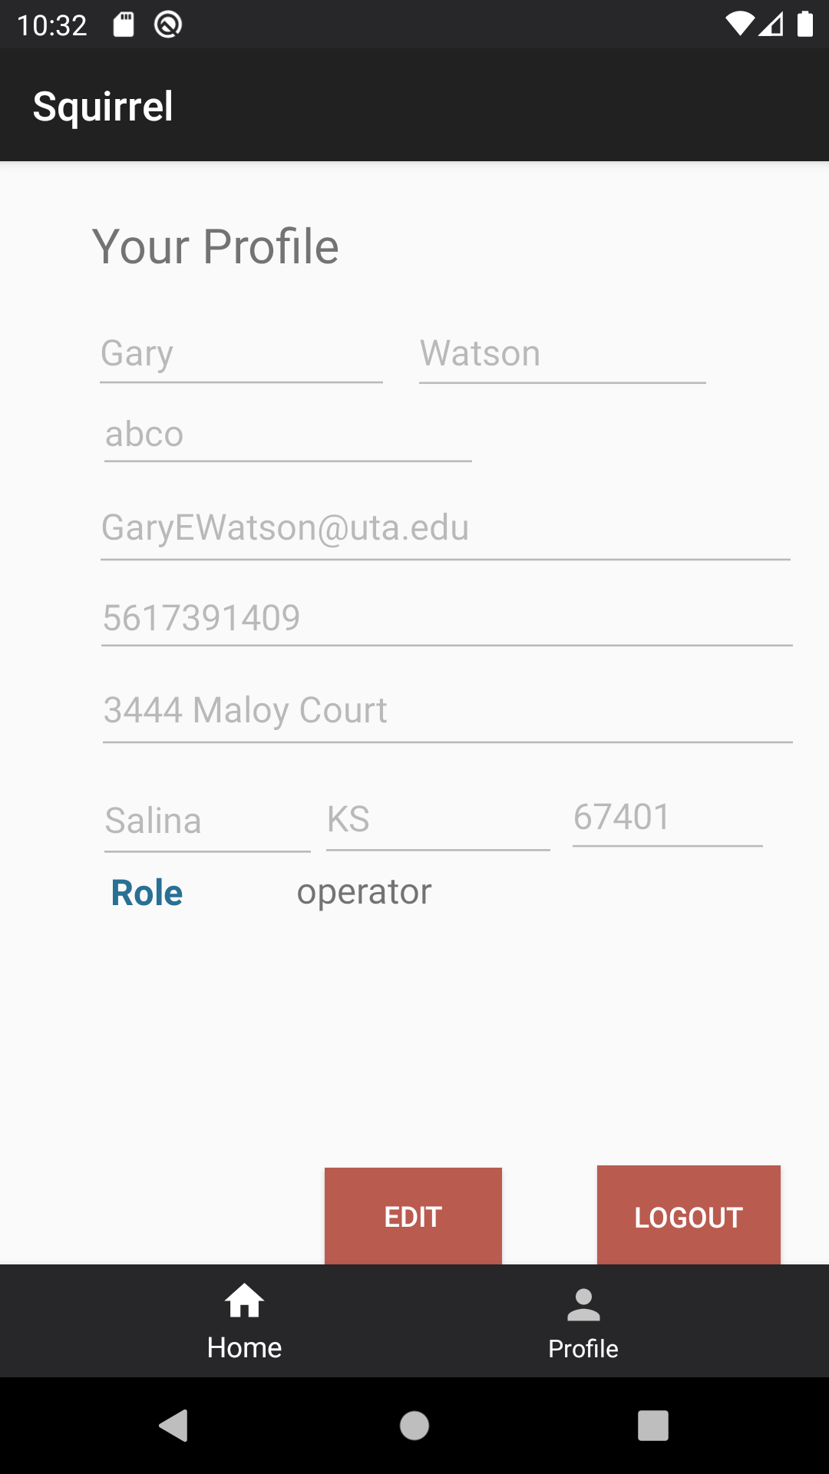r View Profile Screen)

**UC 5: Update Profile**

|  |  |
| --- | --- |
| **Precondition: The system shows system user as logged in. (General for all users)** | |
| **Actor: System User** | **System: Squirrel** |
|  | 0.System Displays the view profile screen (figure 16). |
| 1. **TUCBW** The System User selects the edit function. | 1. System displays the editable fields on the View Profile Screen (figure 17). |
| 1. The System user update one or more fields (after clicking on edit button) and selects update profile. | *4. System updated the user profile with new values and displays the successful message ‘Updated Successfully’ (figure 18). |
| **5.TUCEW** System user see successfully update profile message. The user can return to the application home screen through the bottom navigation. |  |
| **Post condition: The system will update the values of the logged in system user. (General for all users)** | |

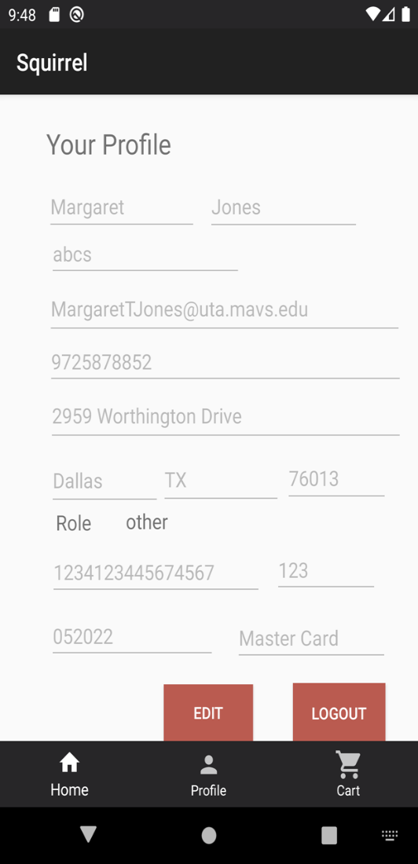

Figure 16 Figure 17

Figure 18

**UC 6: View List of Vehicles**

|  |  |
| --- | --- |
| **Precondition: The system shows Student/ Staff/ Faculty/non-student as already logged in.** | |
| **Actor: Student /Staff/ Faculty/non-student** | **System: Squirrel** |
|  | 0.System displays the home screen (figure 19). |
| **1. TUCBW** The Student/ Staff/ Faculty/non-student can navigate through top bar navigation to switch between Food Truck list of vehicles or Food Cart list of vehicles. | *2.System displays the list of vehicles based on the active tab. (Vehicle Name, Vehicle Type, Location,  Beginning and Ending Time).  (i) Student/ Staff/ Faculty/non-student have tapped on Food Truck bar. System displays list of Food Trucks. (figure 20).  (ii) Student/ Staff/ Faculty/non-student have tapped on Food Cart bar. System displays list of Food Carts. (figure 21). |
| **3.TUCEW** Student/ Staff/ Faculty/non-student can view list of vehicles successfully. And navigate back to the home screen from bottom navigation. |  |
| **Post condition: The system displays list of vehicles for the Student/ Staff/ Faculty/non-student.** | |

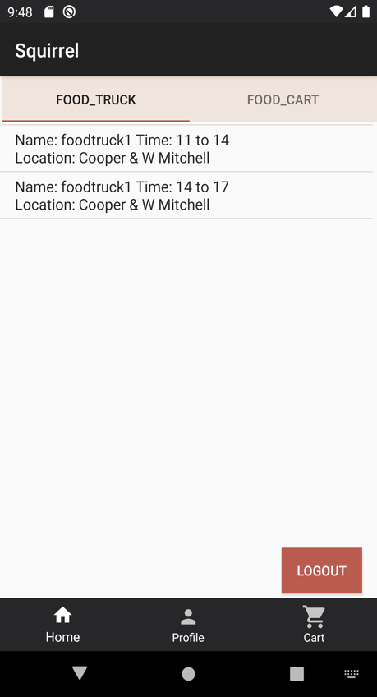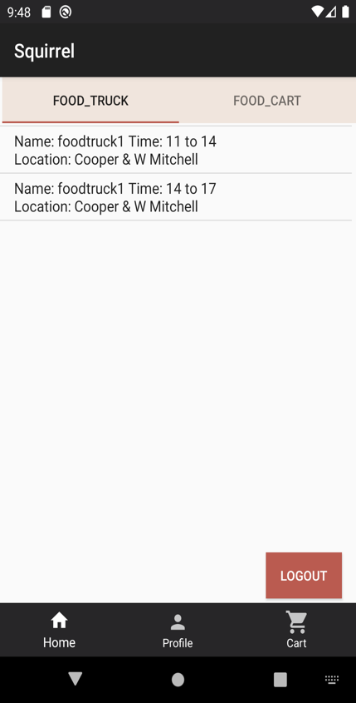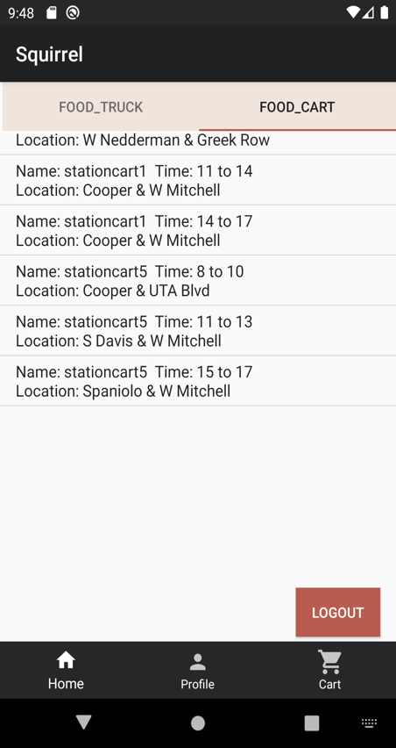

Figure 19 Figure 20 Figure 21

**UC 7: View Inventory**

|  |  |
| --- | --- |
| **Precondition: The system shows Student/ Staff/ Faculty/non-student as already logged in.** | |
| **Actor: Student/ Staff/ Faculty/non-student** | **System: Squirrel** |
|  | 0. System displays the view list of vehicles screen based on the active tab (Food truck and food cart). (Vehicle Name, Vehicle Type, Location,  Beginning and Ending Time).  (figure 22). |
| **1. TUCBW** The Student/ Staff/ Faculty/non-student selects on the specific vehicle from the list of available food trucks and/or available food carts. | *2.System displays the list of available inventory based on the selected vehicle. (Item cost, item names, Item quantity) and also displays the Add to Cart functionality.  (figure 23). |
| **3.TUCEW** Student/ Staff/ Faculty/non-student can successfully see the view inventory screen and if choses, the Student/ Staff/ Faculty/non-student can return to Home screen from bottom navigation |  |
| **Post condition: The system displays list of available inventory for selected vehicle to the Student/ Staff/ Faculty/non-student.** | |

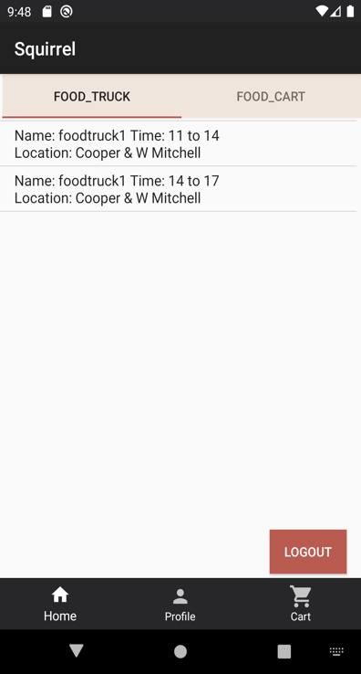 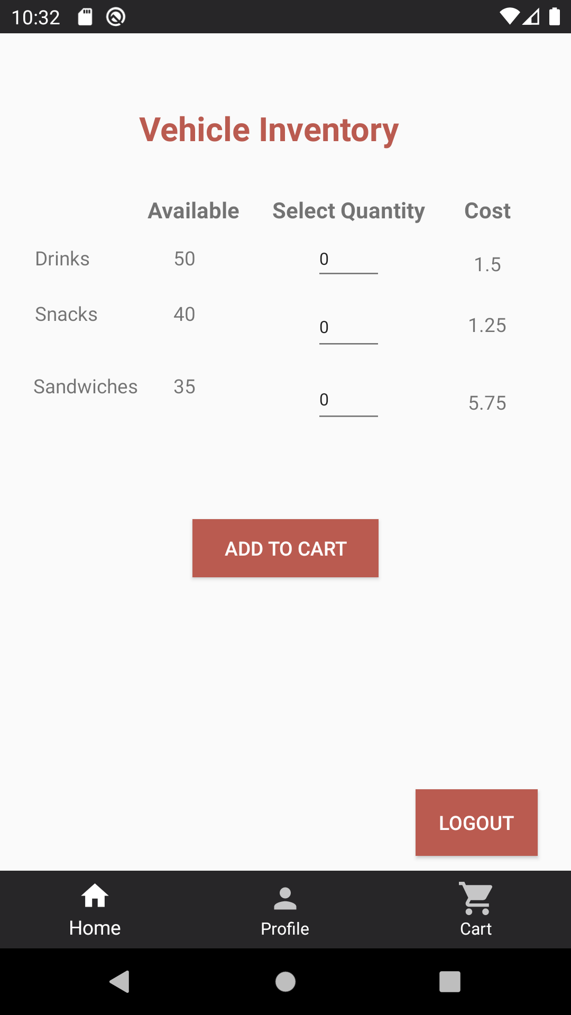

Figure 22 Figure 23

**UC 8: Add to Cart**

|  |  |
| --- | --- |
| **Preconditions:**  **-The system shows Student/ Staff/ Faculty/non-student as already logged in.**  **- The system is displaying the View Inventory screen for the chosen vehicle by Student/ Staff/ Faculty/non-student.** | |
| **Actor: Student/ Staff/ Faculty/non-student** | **System: Squirrel** |
|  | 0. System displays the view inventory screen (Item cost, item names, Item quantity). (figure 24). |
| **1. TUCBW** The Student/ Staff/ Faculty/non-student selects the quantity for desired the item type. | 2.System displays Student/ Staff/ Faculty/non-student selected quantity of items (figure 25). |
| 3.The Student/ Staff/ Faculty/non-student selects add to cart. | *4. System displays the successful message to the Student/ Staff/ Faculty/non-student “Item (Name) successfully added”. (figure 26). |
| **5.TUCEW** Student/ Staff/ Faculty/non-student can successfully see the toast massage from the system that items has been add to the shopping cart. And navigate back to the home screen from bottom navigation. |  |
| **Post condition: The system adds the chosen items and their quantities for a specific vehicle to the cart.** | |

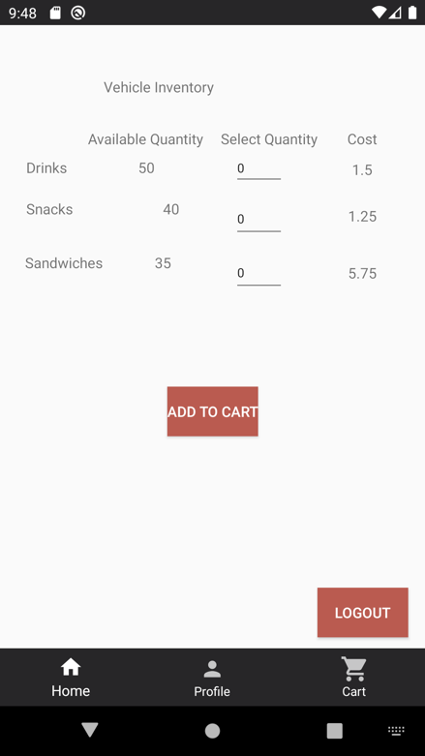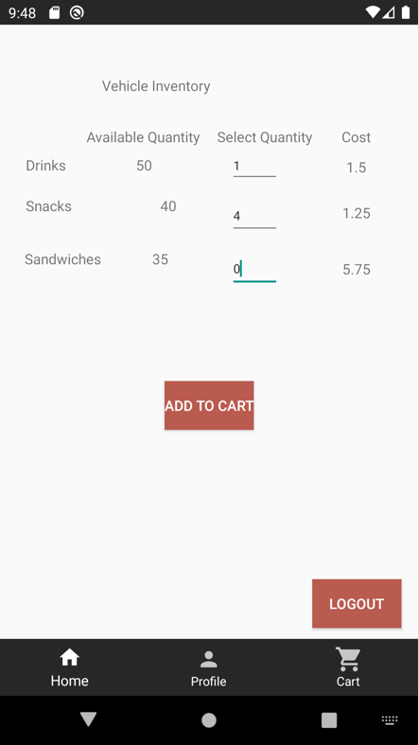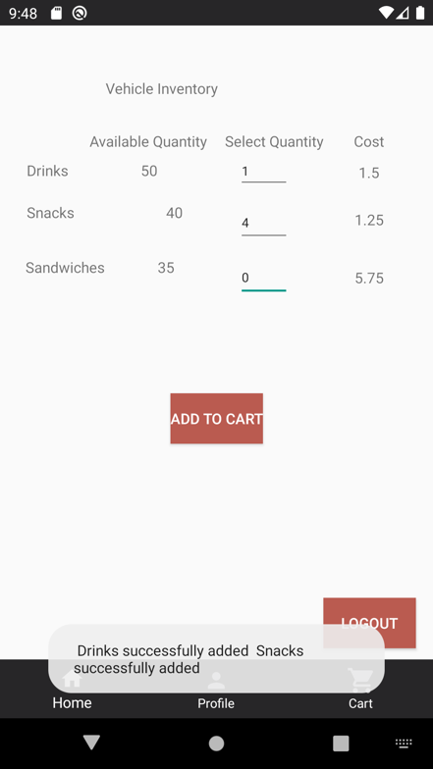

Figure 24 Figure 25 Figure 26

**UC 9: Modify/ View Cart**

|  |  |
| --- | --- |
| **Precondition:**  **-The system shows Student/ Staff/ Faculty/non-student as already logged in.** | |
| **Actor: Student/ Staff/ Faculty/non-student** | **System: Squirrel** |
|  | 0. System displays the home screen for the System user.  (figure 27). |
| **1. TUCBW** The Student/ Staff/ Faculty/non-student selects shopping cart (cart functionality) accessible from all screens through the bottom navigation bar. | 2.System displays the list of items added to the Student/ Staff/ Faculty/non-student cart including (item Name, item type, quantity for each item, cost per item, total cost for all items) (figure 28). |
| 3. The Student/ Staff/ Faculty/non-student sees the items in the cart successfully. The Student/ Staff/ Faculty/non-student can modify one or more fields in their cart (remove and item, update quantity). | *4. The system display the updated cart information (if any update has been done by the Student/ Staff/ Faculty/non-student).  (figure 29) |
| **5.TUCEW** Student/ Staff/ Faculty/non-student can successfully see the updated shopping cart. Student/ Staff/ Faculty/non-student can go to checkout screen or navigate back to home screen (view list of vehicle) from the bottom navigation bar. |  |
| **Post condition: The system will update the cart values based on Student/ Staff/ Faculty/non-student input. And display the most updated result to the Student/ Staff/ Faculty/non-student.** | |

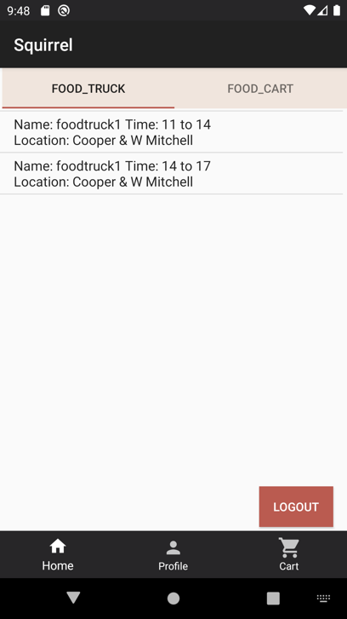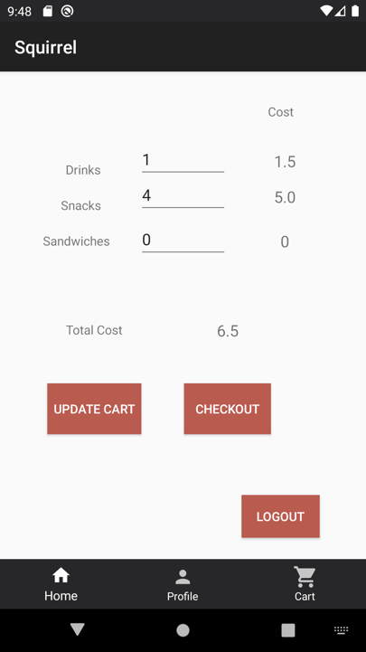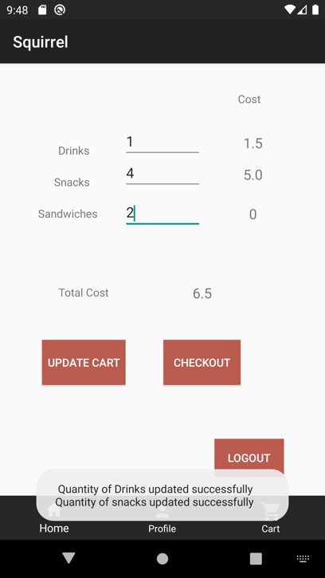

Figure 27 Figure 28 Figure 29

**UC 10: Checkout**

|  |  |
| --- | --- |
| **Precondition:**  **-The system shows Student/ Staff/ Faculty/non-student as already logged in.**  **- The system saved users cart information in the cart. The system directs user from cart to checkout.** | |
| **Actor: Student/ Staff/ Faculty/non-student** | **System: Squirrel** |
|  | 0. System displays the checkout screen. (item, quantity and total cost)  (figure 30). |
| **1. TUCBW and TUCEW** The Student/ Staff/ Faculty/non-student review the quantity, items and total cost. User can select to go to payment method screen or navigate back to cart, and home page from bottom navigation. |  |
| **Post condition: The system will display the checkout summary to the Student/ Staff/ Faculty/non-student.** | |

Figure 30

**UC 11: Add/ Modify Card Information**

|  |  |
| --- | --- |
| **Precondition:**  **-The system shows Student/ Staff/ Faculty/non-student as already logged in.**  **- The system directs user from checkout to payment method screen.** | |
| **Actor: Student/ Staff/ Faculty/non-student** | **System: Squirrel** |
|  | 0. System displays the payment method screen. (card summary: card number, expiration date, type, and CVV)  (figure 31). |
| **1. TUCBW** The Student/ Staff/ Faculty/non-student review the card summary. If the user has not entered the card before in profile, the user could select add/modify card and add details in profile. Else, the user can add the correct CVV number and select place the order. | *2. The system will display toast message if CVV is empty (figure 32). Also, it will give another toast message if CVV is not correct with previous card entry in database (figure 33).  Else, the system will generate order id number and directs the user to Success payment screen.(Figure 34) |
| **3. TUCEW** The Student/ Staff/ Faculty/non-student sees the order number id and success message. The user can navigate back to home screen from bottom navigation. |  |
| **Post condition: The system will place the order and update payment, cart, and inventory table in the database. And the system will display order id along with success message to the Student/ Staff/ Faculty/non-student.** | |

Figure 31 Figure 32 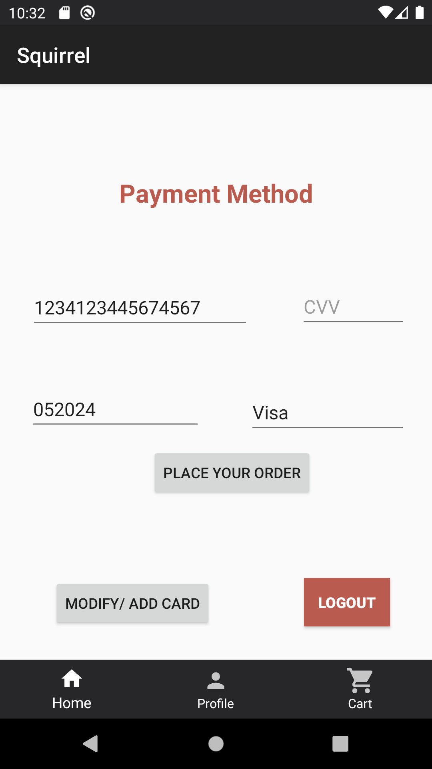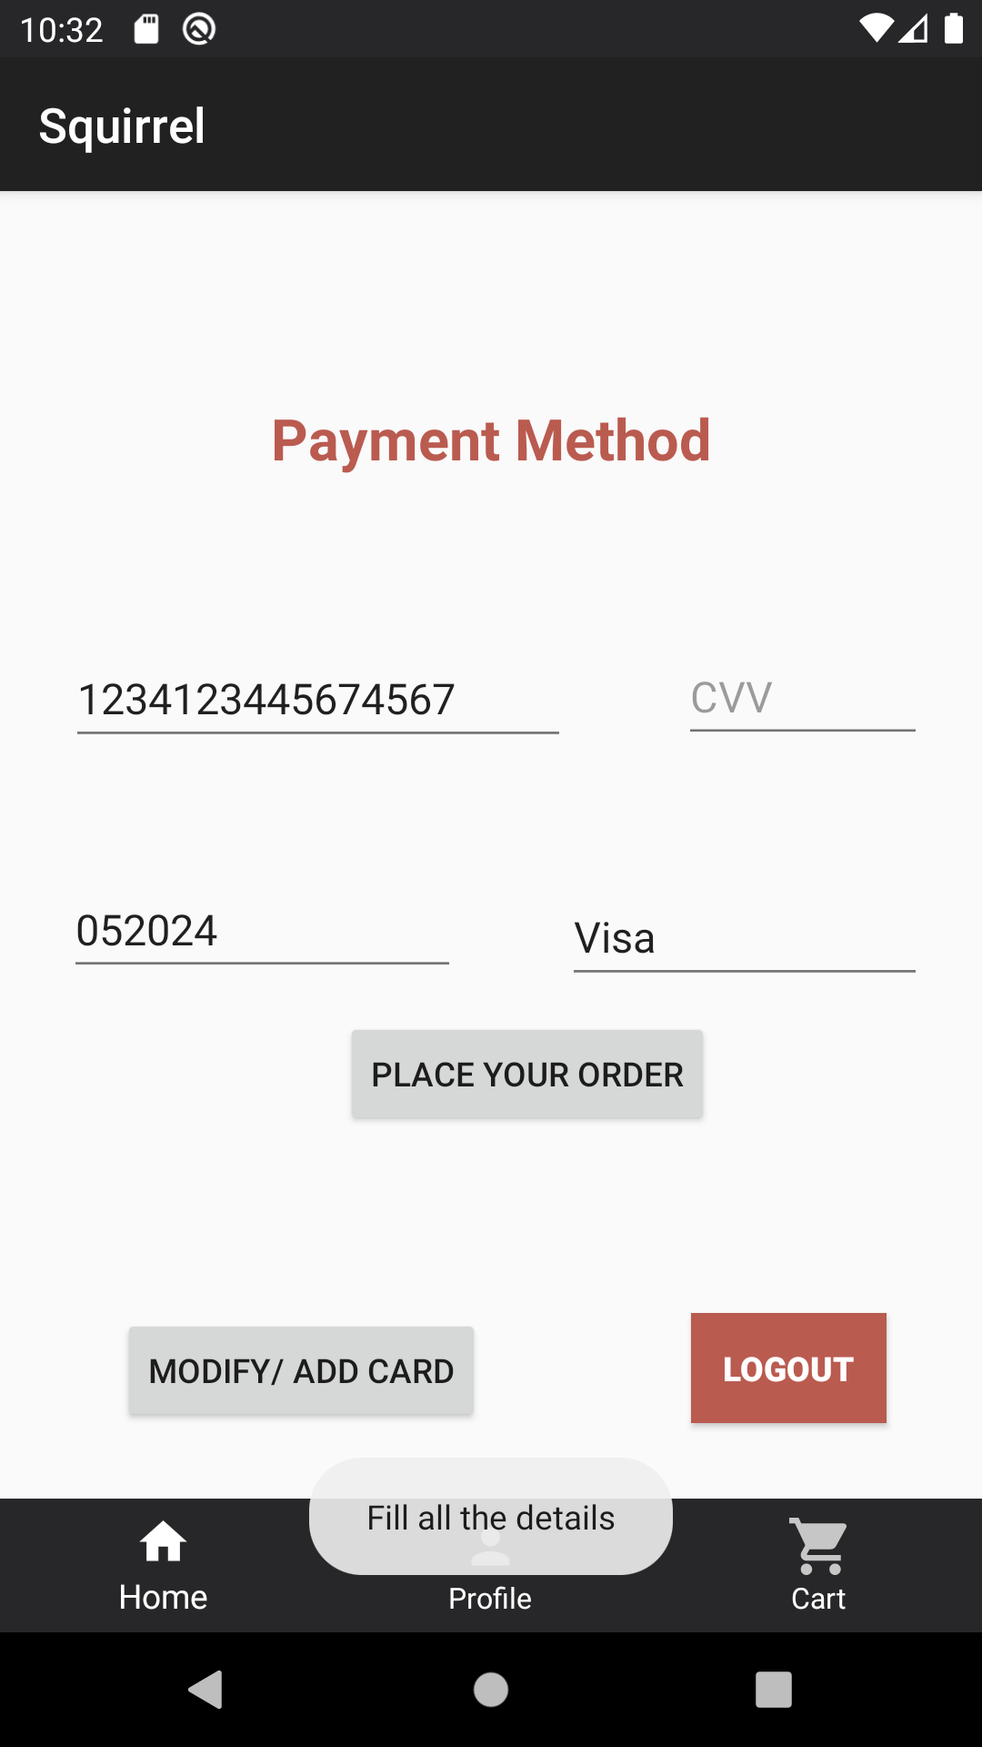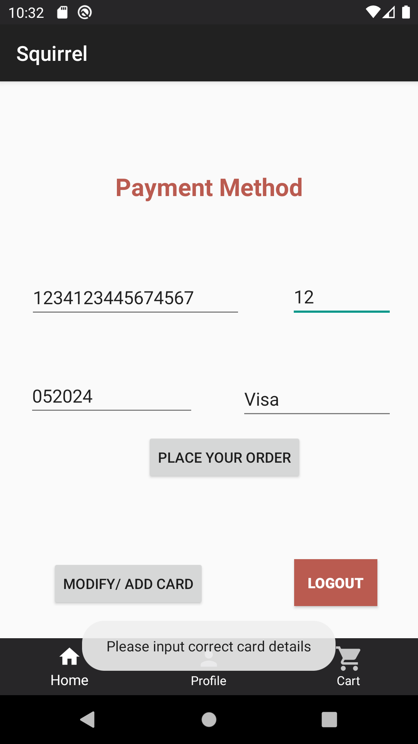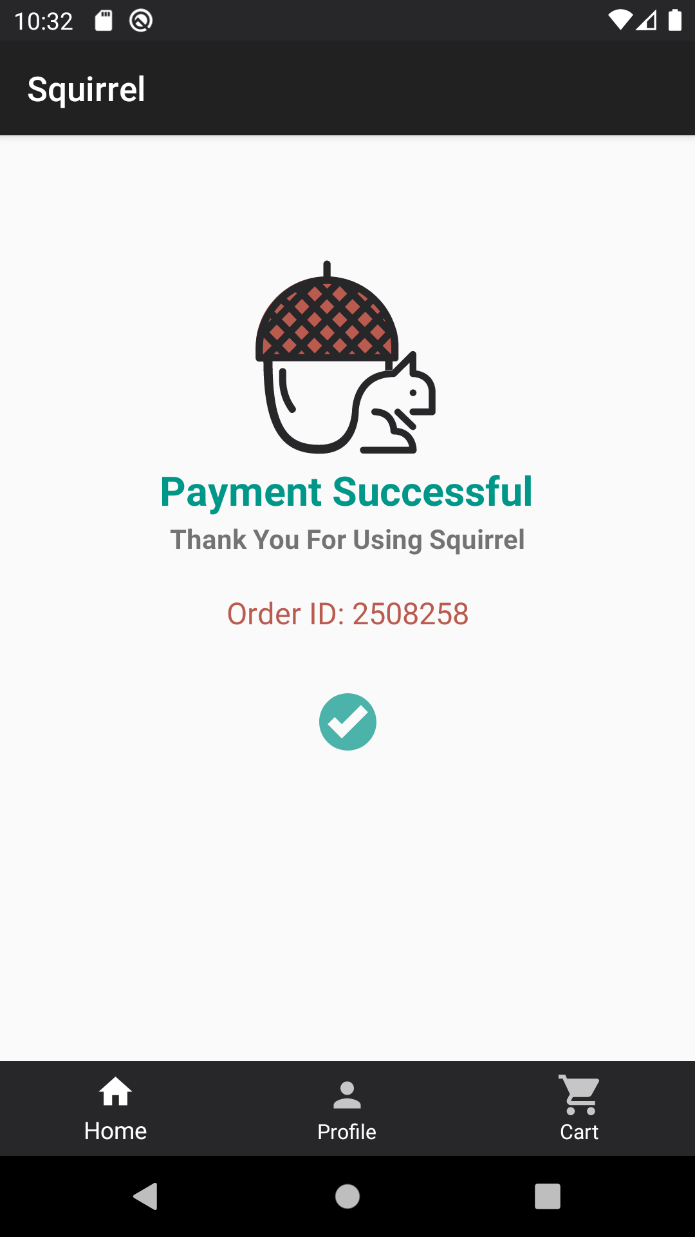 Figure 33

Figure 34

**UC 12: View List of Vehicles**

|  |  |
| --- | --- |
| **Precondition: The system shows the Vending Manager as already logged in.** | |
| **Actor: Vending Manager** | **System: Squirrel** |
|  | 0. System displays the home screen for the Vending Manager.  (figure 35). |
| **1. TUCBW** The Vending Manager select the vehicle icon (function) from the home screen. | *2. System displays the list of Vehicles including (Vehicle Name, Vehicle type, Operator First Name, Operator Last Name, Location, Schedule Date, Slot Begin, Slot End)  (figure 36). |
| **3.TUCEW** The Vending Manager can successfully see the list of vehicles. And Vending Manager can navigate back to the home screen from bottom navigation. |  |
| **Post condition: The system will display list of all vehicles sorted by vehicle id in DB through database query.** | |

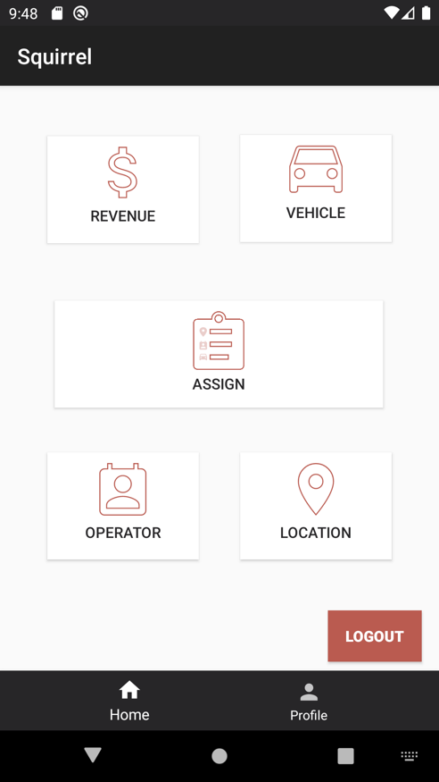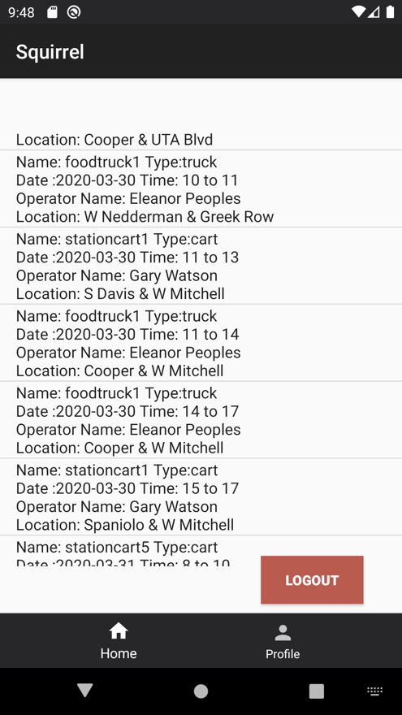

Figure 35 Figure 36

**UC 13: View/ Modify Vehicles Inventory**

|  |  |
| --- | --- |
| **Precondition:**  **-The system shows the Vending Manager as already logged in.** | |
| **Actor: Vending Manager** | **System: Squirrel** |
|  | 0. System displays view list of vehicles screen. (figure 36). |
| **1. TUCBW** The Vending Manager select the vehicle of his choice. | 2.System displays the inventory for the selected vehicle on view/ modify vehicle inventory screen. (quantity, cost, item name) (figure 37). |
| 3. Vending Manager can update one or more fields (quantity and/ or cost) per item type When Vending Manager selects the Update. Or he can only view the list of inventories. | *4. System displays the inventory for the selected vehicle or in case of update, the updated inventory will be displayed. And it will generate a success toast. (figure 38). |
| **5.TUCEW** Vending Manager can successfully see the updated inventory for the selected vehicle. Vending Manager can navigate back to home screen through bottom navigation. |  |
| **Post condition: The system will update the inventory values and displays the updated inventory to the Vending Manager for the selected vehicle.** | |

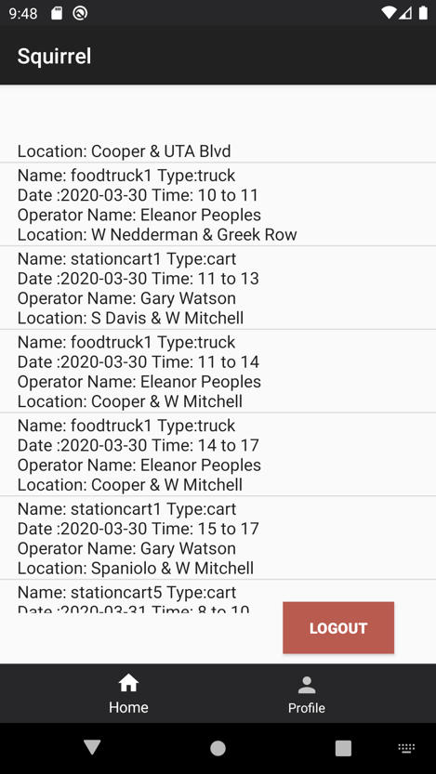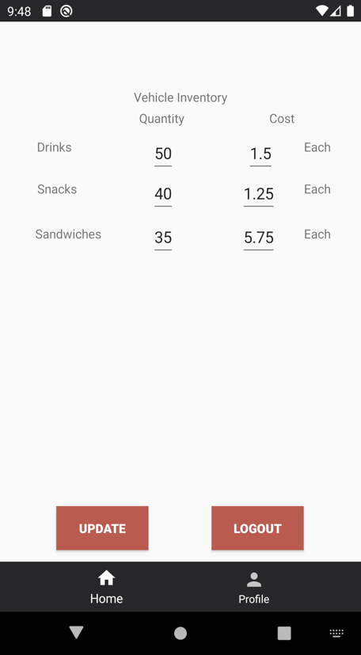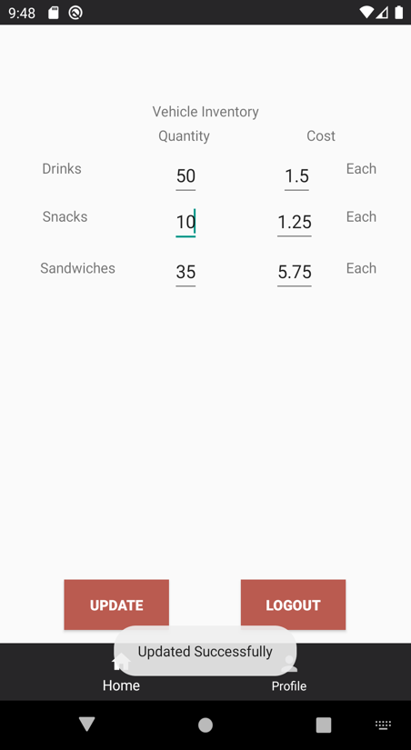Figure 36 Figure 37 Figure 38

**UC 14: View Vehicle Revenue**

|  |  |
| --- | --- |
| **Precondition:**  **-The system shows the Vending Manager as already logged in.** | |
| **Actor: Vending Manager** | **System: Squirrel** |
|  | 0. System displays home screen.  (figure 39). |
| **1. TUCBW** The Vending Manager select the revenue function. | *2. System displays the revenue on view vehicle revenue screen Sorted by vehicle Name (ASC) throughdatabase. (Vehicle Name, Operator First Name, Operator Last Name, Payment Date, Total Revenue (Per vehicle), Sum of revenue for all vehicles) for current day vehicle. (figure 40). |
| **3.TUCEW** Vending Manager can successfully see the revenue for each vehicle and sum of revenue for current day vehicles together. And can navigate back to the home screen from bottom navigation. |  |
| **Post condition: The system will display vehicle revenue sorted by vehicle Name (ASC) through database to the Vending Manager.** | |

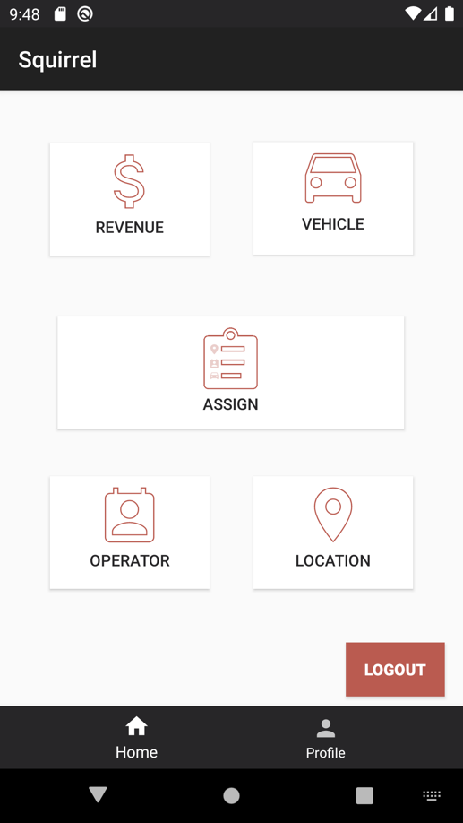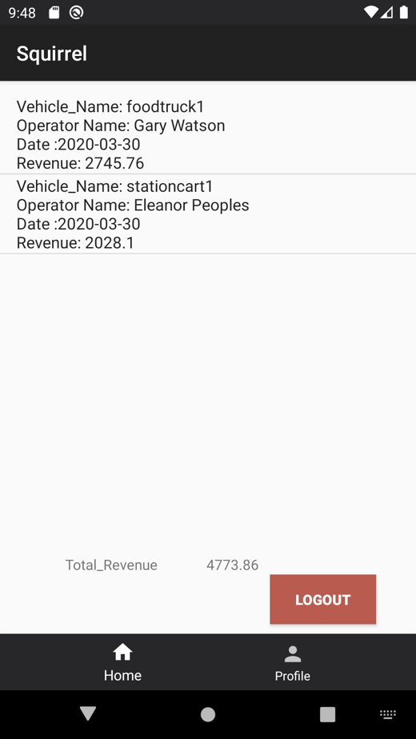

Figure 39 Figure 40

**UC 15: Modify Vehicle Assignment**

|  |  |
| --- | --- |
| **Precondition: The system shows the Vending Manager as already logged in.** | |
| **Actor: Vending Manager** | **System: Squirrel** |
|  | 0. System displays home screen. (figure 41). |
| **1. TUCBW** The Vending Manager select the assign function. | 2.Systm displays the assign screen  (figure 42). |
| 3. Vending Manager selects the vehicle from vehicle list, location from location list, operator from operator list, start time from the time list.(Drop down menu) | *4. System displays the selected vehicle (Vehicle Name, Vehicle Id), selected location (Location Id, Location Address, Duration), selected operator (Operator Id, Operator Name), selected start time (Start Time, End time (given by default to user)) (figure 43). |
| **5.TUCEW** Vending Manager can successfully assign the chosen field if there is no conflict. The system will prompt Vending Manager if the assign is successful or if it is invalid. And can navigate back to the home screen from bottom navigation. |  |
| **Post condition: The system will display assigned information to the Vending Manager and update the values in the system.** | |

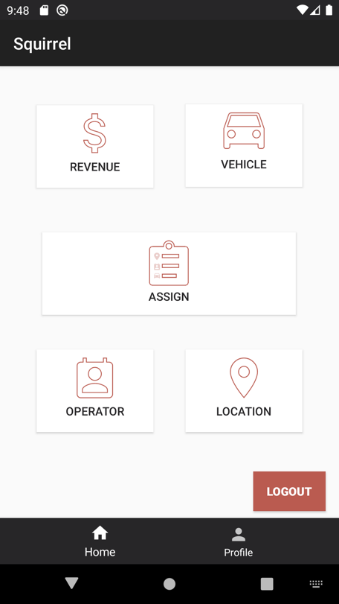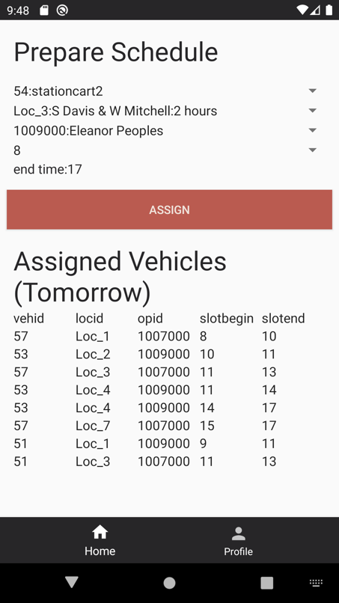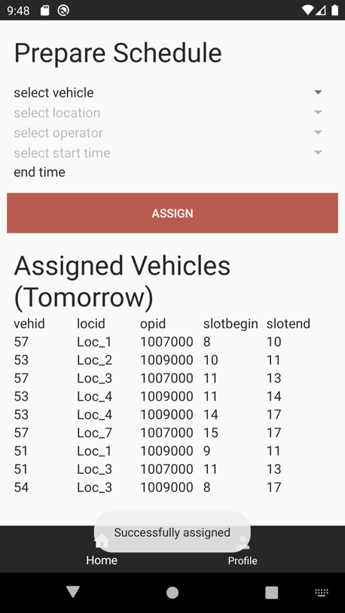

Figure 41 Figure 42 Figure 43

**UC 19: View Operator**

|  |  |
| --- | --- |
| **Precondition: The system shows the Vending Manager as already logged in.** | |
| **Actor: Vending Manager** | **System: Squirrel** |
|  | 0. System displays home screen.  (figure 44). |
| **1. TUCBW** The Vending Manager select the operator function. | 2.System displays the operator screen (Operator First Name, Operator Last Name, Vehicle Name, Location, Slot Begin, Slot End) sorted by operator First Name (figure 45). |
| **3.TUCEW** Vending Manager can successfully see the list of assigned vehicles to every assigned operator with the time schedule information. And can navigate back to the home screen from bottom navigation. |  |
| **Post condition: The system will display the list of assigned operators to their vehicles sorted by operator First Name to the Vending Manager.** | |

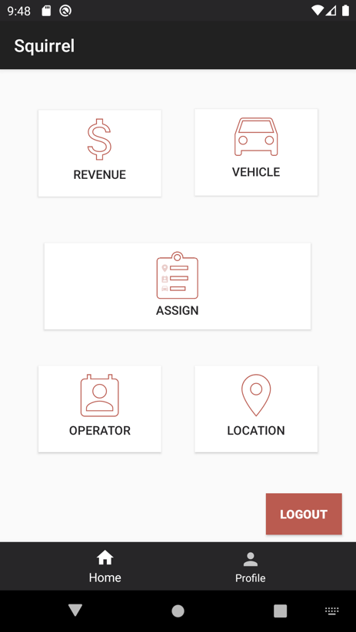

Figure 44 Figure 45

**UC 20: Modify Operator**

|  |  |
| --- | --- |
| **Precondition:**  **-The system shows the Vending Manager** **as already logged in.**  **- The system is displaying the View operator screen.** | |
| **Actor: Vending Manager** | **System: Squirrel** |
|  | 0. System displays view operator screen (Operator First Name, Operator Last Name, Vehicle Name, Location, Slot Begin, Slot End) (figure 46). |
| **1. TUCBW** Vending Manager select the list item which he wants to change. | 2.System displays the modify operator screen (Operator First Name, Operator Last Name, Vehicle Name, Location, Slot Begin, Slot End) (figure 47). |
| 3. Vending Manager can update the assigned vehicle from available vehicle list by selecting “UPDATE ASSIGNED VEHICLE”. | *4. System displays updated information (Operator First Name, Operator Last Name, Vehicle Name, Location, Slot Begin, Slot End) and displays a confirmation message to Vending Manager. (figure 48). |
| **5.TUCEW** Vending Manager see confirmation update profile message. And user can navigate back to the home screen from bottom navigation. |  |
| **Post condition: The system will display the updated values to the Vending Manager and update in system.** | |

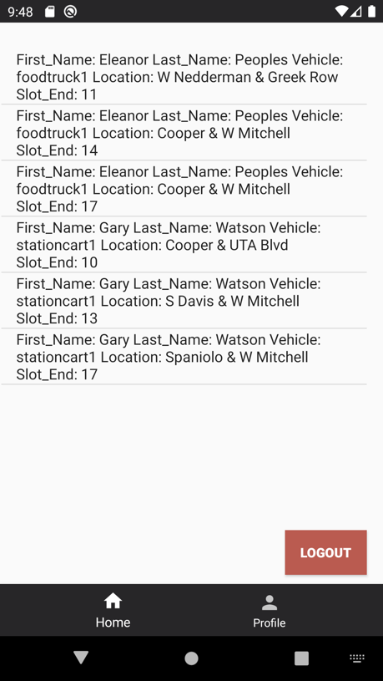 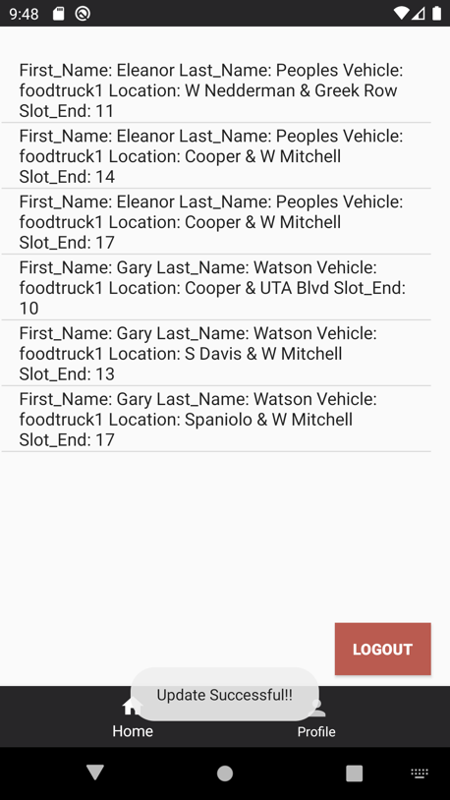

Figure 46 Figure 47 Figure 48

**UC 21: View Location**

|  |  |
| --- | --- |
| **Precondition:**  **-The system shows the Vending Manager** **as already logged in.** | |
| **Actor: Vending Manager** | **System: Squirrel** |
|  | 0. System displays home screen.  (figure 49). |
| **1. TUCBW** The Vending Manager select the location function. | *2. System displays the list of locations to the Vending Manager sorted by Location Id. (Location ID, location Name, Duration.)  (figure 50). |
| **3.TUCEW** Vending Manager can successfully see the list of locations. Vending Manager can navigate back to home screen through bottom navigation. |  |
| **Post condition: The system will display all locations for the Vending Manager.** | |

Figure 49 Figure 50

**UC 22: Modify Location**

|  |  |
| --- | --- |
| **Precondition: The system shows the Vending Manager** **as already logged in.** | |
| **Actor: Vending Manager** | **System: Squirrel** |
|  | 0. System displays view location screen. (figure 51). |
| **1. TUCBW** Vending Manager select one specific location to modify that location and selects “Edit” functionality. | 2.System displays the modify location screen for the selected location. (Location ID,Location Name, Duration)  (figure 52). |
| 3. Vending Manager can modify the location’s name or the location duration for selected location by selecting “SAVE”. | *4. System displays updated information on that location and provide a success toast to the Vending Manager. (figure 53). |
| **5.TUCEW** Vending Manager can successfully see the updated location and by default will be navigate back to view location screen. And Vending Manager can navigate back to the home screen from bottom navigation. |  |
| **Post condition: The system will update the location value for the selected location and displays the updated information to the Vending Manager.** | |

Figure 51 Figure 52 Figure 53

**UC 23: View Vehicles Schedule**

|  |  |
| --- | --- |
| **Precondition: The system shows the actor as already logged in.** | |
| **Actor: Vending Operator** | **System: Squirrel** |
|  | 0. System displays view vehicle schedule to the System user. (Vehicle name, Vehicle Type, Location, Location, Slot begin, Slot end, Total revenue) (figure 54). |
| **1. TUCBW and TUCEW** The System user view his assigned vehicle schedule. And user can navigate back to the home screen from bottom navigation. |  |
| **Post condition: The system will display the vehicle schedule to the Vending Operator.** | |

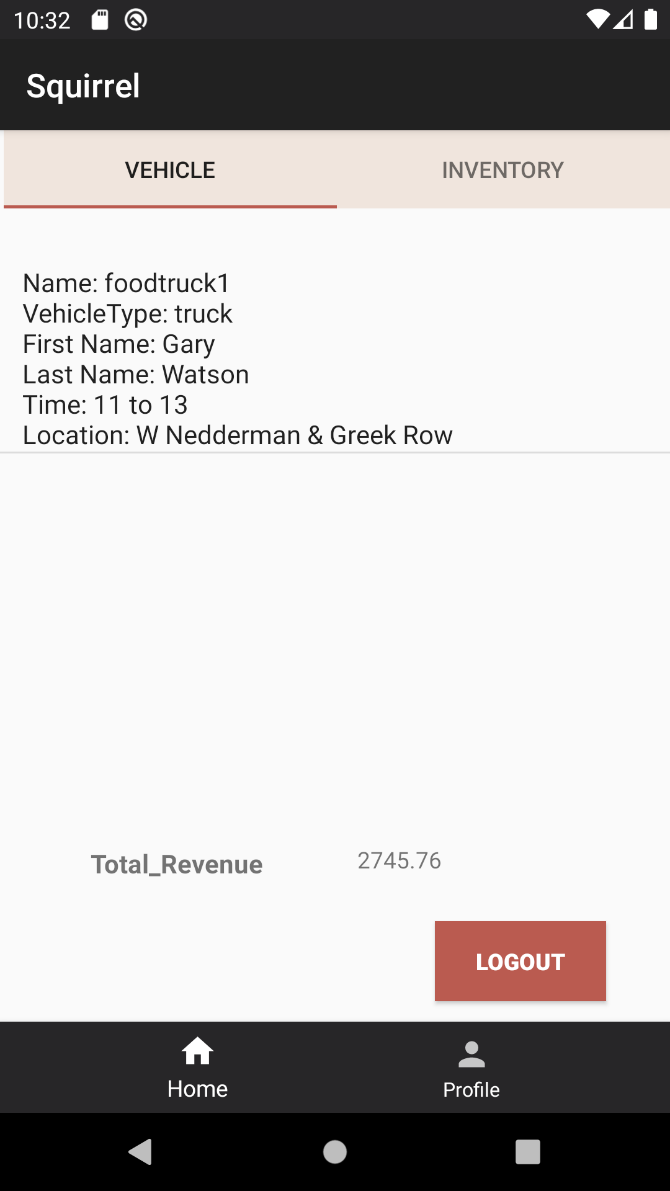

Figure 54

**UC 24: View/ Modify Vehicles Inventory**

|  |  |
| --- | --- |
| **Precondition: The system shows the actor as already logged in.** | |
| **Actor: Vending Operator** | **System: Squirrel** |
|  | 0. System displays home screen  (figure 55). |
| **1. TUCBW** The System user select the vehicle inventory from top bar. | 2.System displays the inventory for the assigned vehicle to operator vehicle on view/ modify vehicle inventory. (quantity, cost, item type)  (figure 56). |
| 3.System user can update one or more fields (quantity) per item type. Or he can only view the list of inventories. | *4. System displays the inventory or in case of update, the updated inventory will be displayed. And it will generate a success toast. (figure 57). |
| **5.TUCEW** System user can successfully see the updated inventory for the selected vehicle. User can navigate back to home screen through bottom navigation or top bar. |  |
| **Post condition: The system will update the inventory values and displays the updated inventory to the Vending Operator for the selected vehicle.** | |

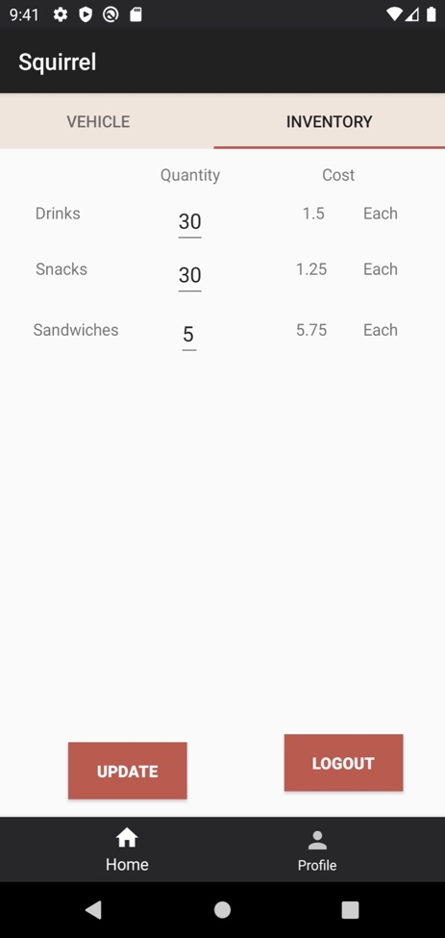

Figure 55 Figure 56

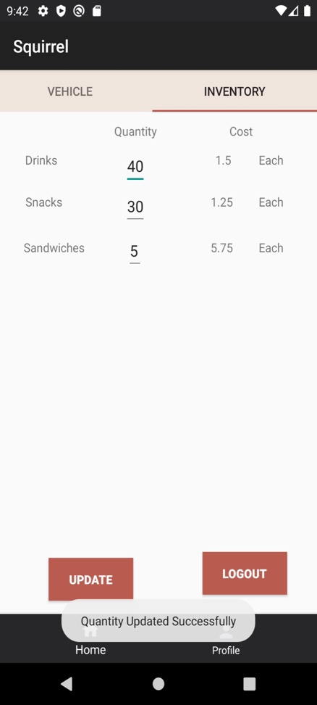

Figure 57